KINGSTON TECHNICAL HIGH SCHOOL PAST STUDENT ASSOCIATION
TORONTO CHAPTER
126 yr. JAMAICA CELEBRATION CEREMONY

TORONTO CHAPTER MEMBERS:”WHERE ARE THEY NOW SEGMENT”

HYACINTH RANDALL Student 1953-1958
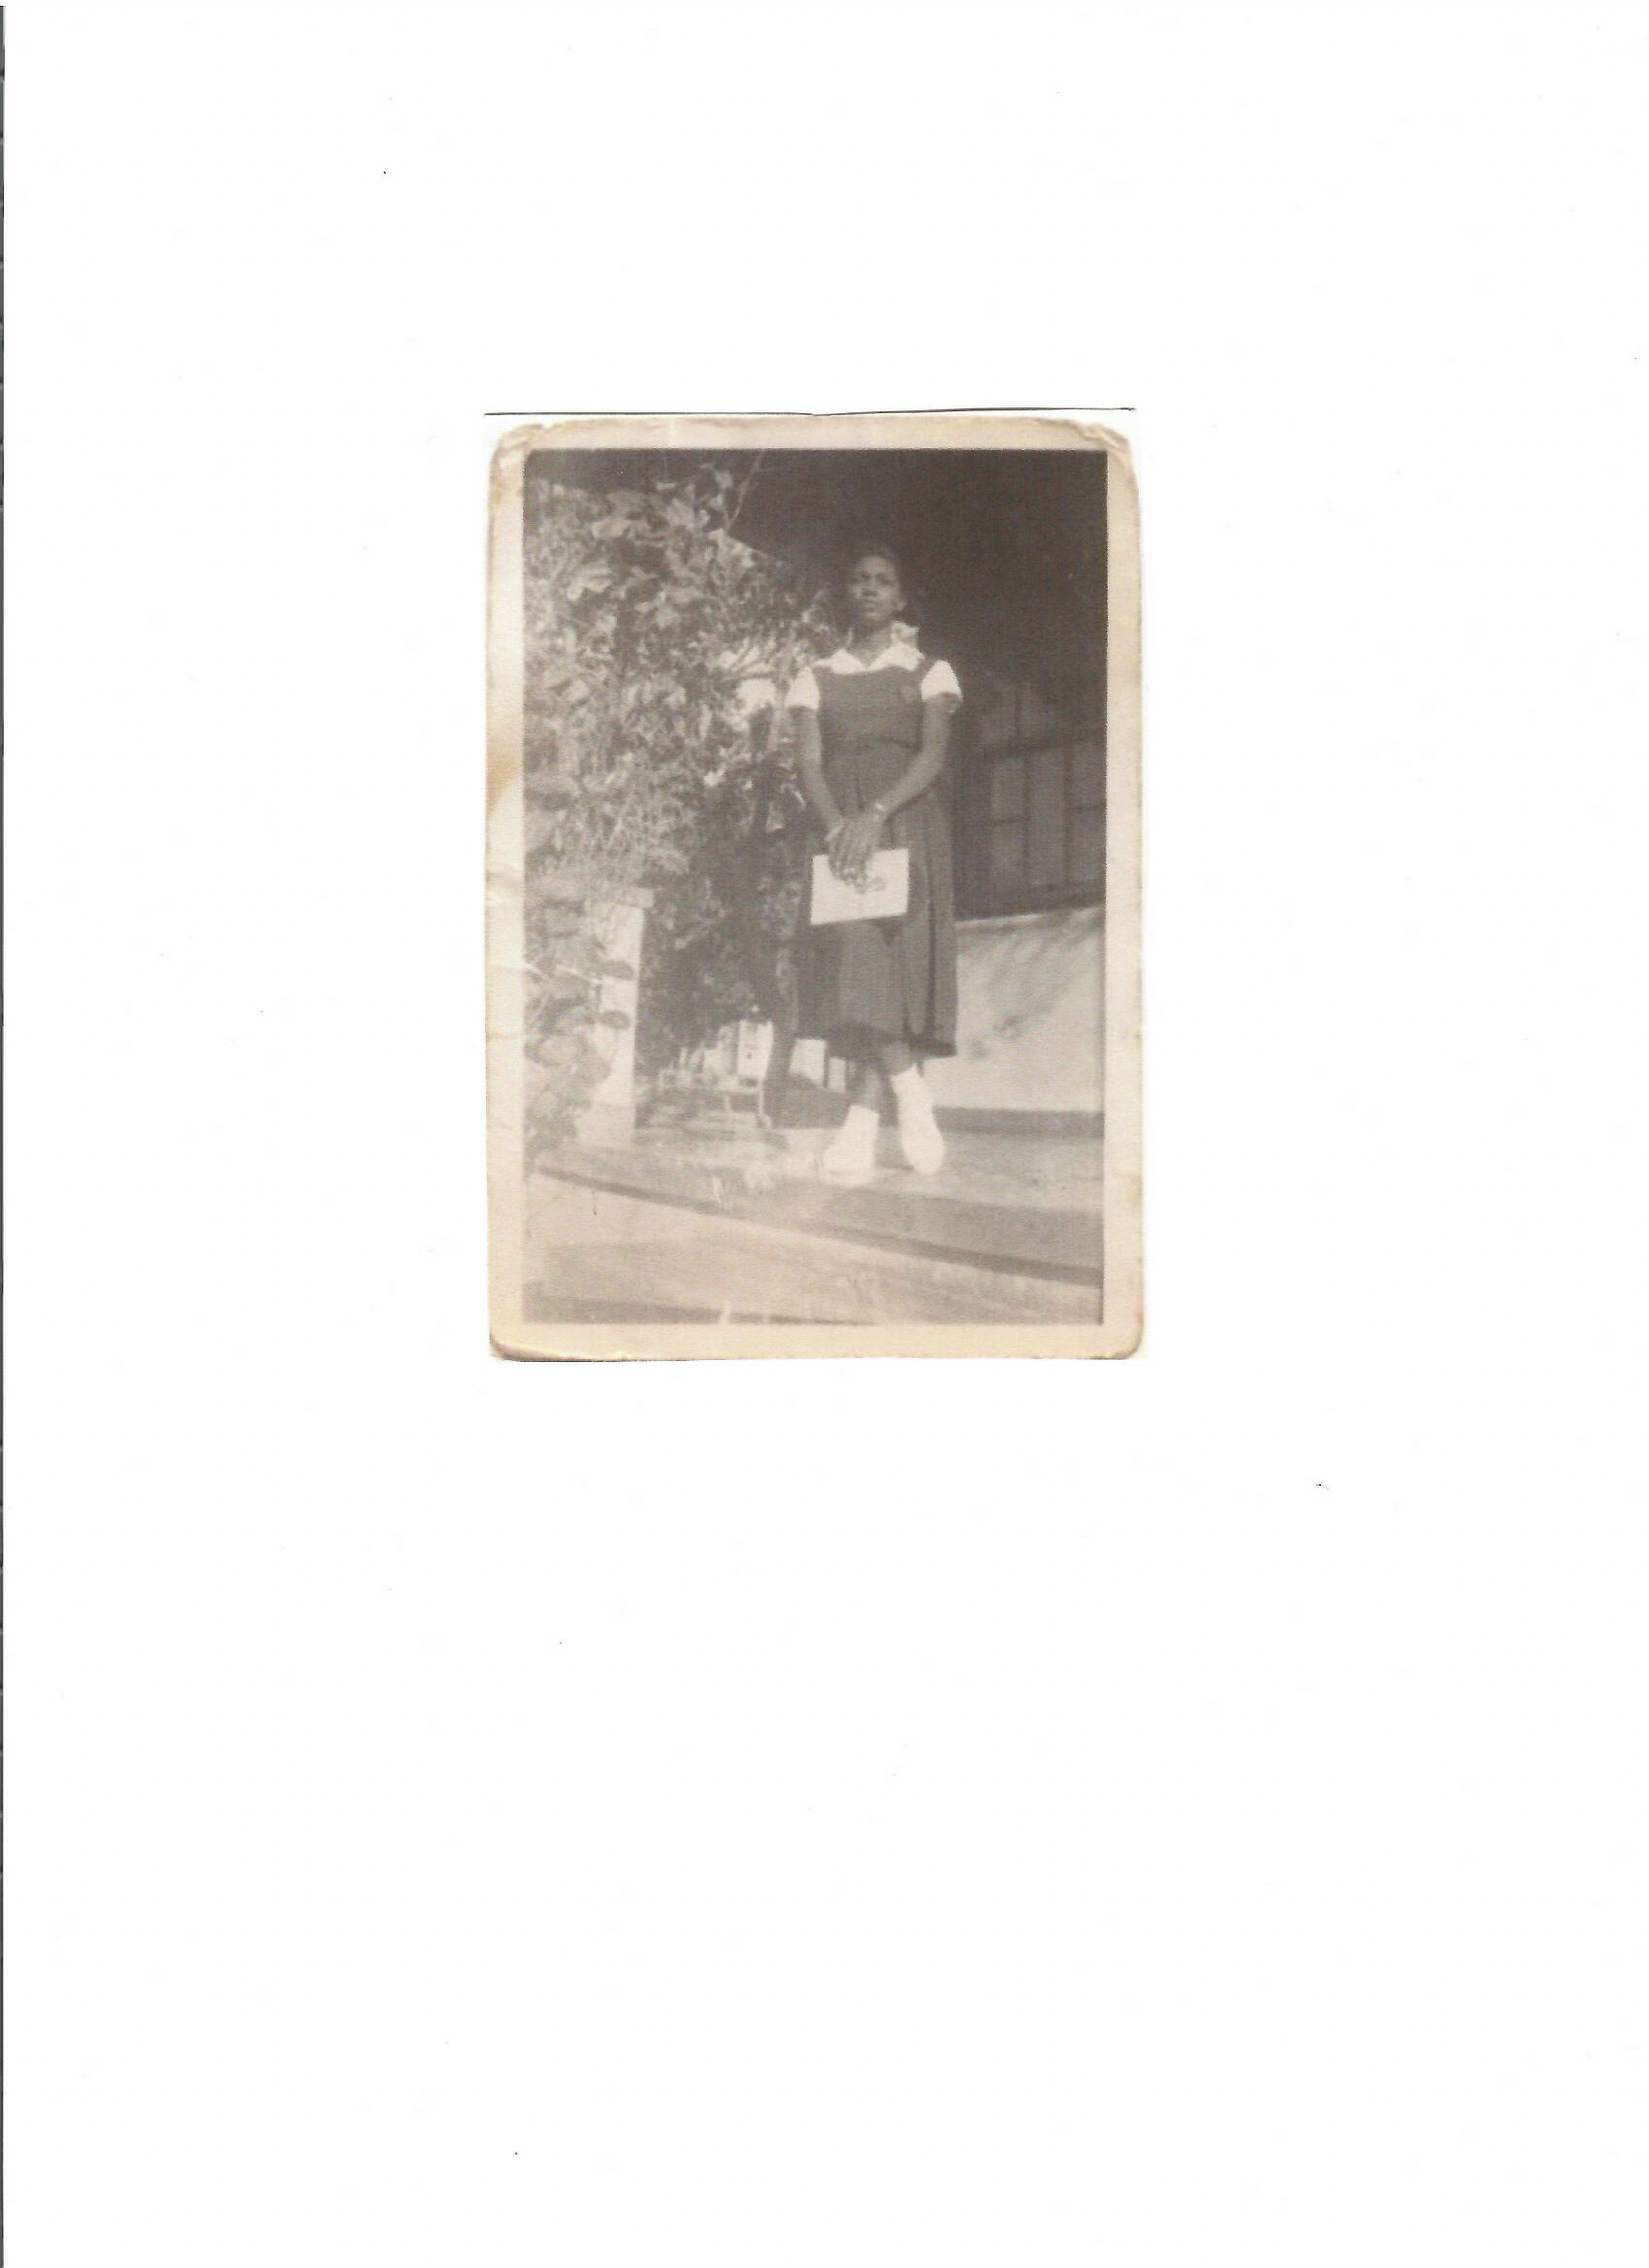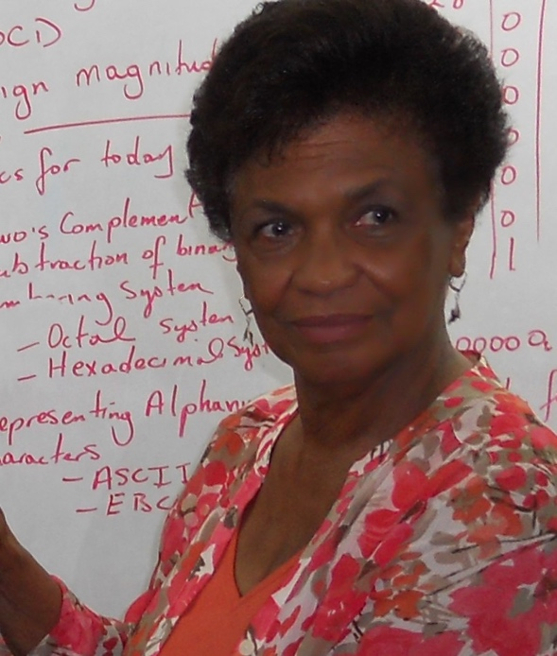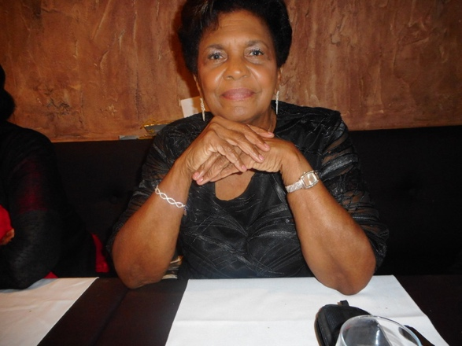

Hyacinth Randall 1953-1958
Hyacinth Randall entered Kingston Technical School in 1953 and spent one year in the Home Economics Department. She was encouraged by her teacher to transfer to the Commercial Department, which was a new class being introduced in the school, which is the present Business Department. She said, “this was probably the best decision she ever made.”

She graduated from Kingston Technical High School in 1958. After graduation she worked in several places, most notable being her first job in the Prime Minister’s office, The Rt.Hon. Norma Manley’s office from 1958 to 1963. Her time in the Business Department opened the doors of opportunities for migration to Canada in 1963 to both work and study.

After attending Seneca College where she studied Business Administration. She was encouraged to pursue Human Resource Training and Development. She worked as an Adult Education Teacher at Seneca College and ultimately moved to British Columbia to finish her studies where she also worked for the Federal and Territorial Governments, as a corporate trainer. She returned to Ontario and accepted the position of professor at Seneca College of Applied Arts and Technology where she presently lectures students in the School of Accounting and Finance, teaching Introduction to Business Administration.

Her most memorable moments at Kingston Technical are the discipline and accountability reinforced in her by her teachers and peers, including her team mates on the softball team. A team that she was honoured to lead to the playoffs victoriously in the 1957-1958 season.

Kingston Technical holds a special place in her heart not only for what she learned then, but the friendships that were established as well as the connections she has today. She is an avid supporter of the school even now, always volunteering her time, as well as finances and facilitating surplus assets from Seneca College providing KTHS with computers, chairs, filing cabinets , etc. She is always ready to help with KTHS Toronto chapter fundraising efforts and ensuring that the legacy that she received and is enjoying to this day continues for the students of today and long into the future.

