KINGSTON TECHNICAL HIGH SCHOOL PAST STUDENT ASSOCIATION
TORONTO CHAPTER
126 yr. JAMAICA CELEBRATION CEREMONY

TORONTO CHAPTER MEMBERS:”WHERE ARE THEY NOW SEGMENT”

WILLIAM WOOLNOUGH 1972-1976

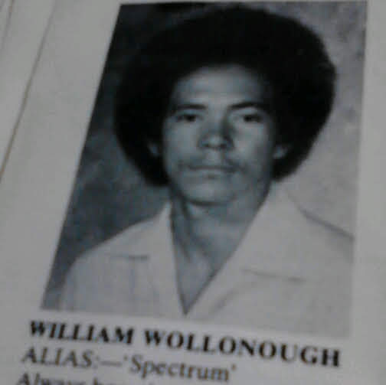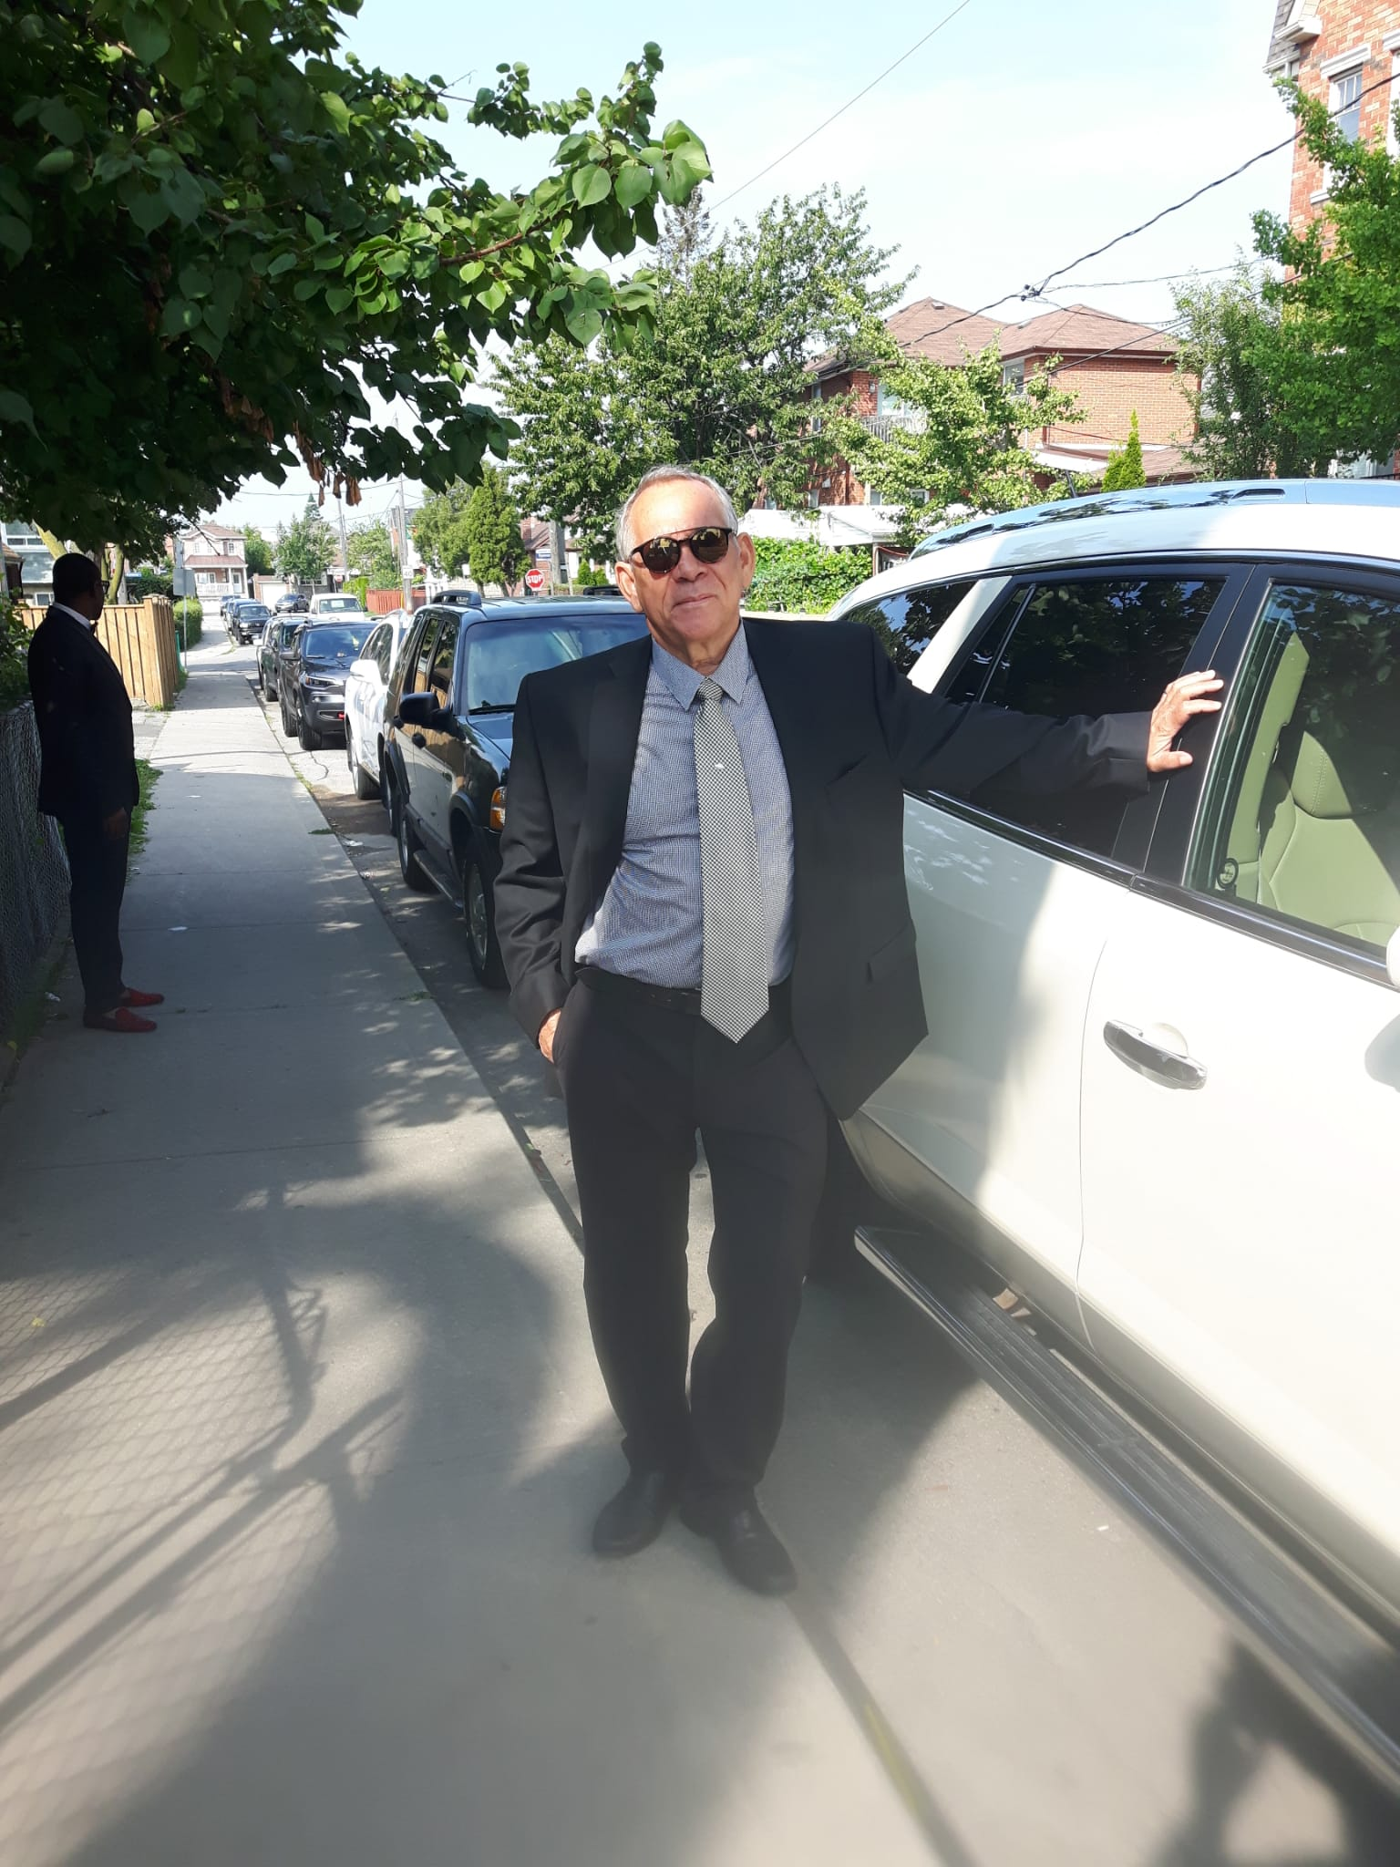
Please note: Name spelt wrong in year book.

William Woolnough attended Kingston Technical High School from 1972 to 1976.
specialising in the Building and Engineering Stream. He was
a member of the KTHS Cricket team as well as a member of the School Challenge Team . He was a member of The executive Board for KTHS Past Student Association from 1975-1979.
After graduating in 1976 he attended The College of Arts Science and Technology Institute now known as University of Technology where he studied Engineering from 1977 to 1979.
While attending CAST he was nominated for Student of the year Award in 1979
and he was also a recipient of the Coats Brothers award.

In 1979 he received a scholarship to attend The Hungary
International Preparatory School to study languages majoring in Hungarian.
He attended Technical University of Budapest from 1980 to 1985, where he graduated with a Masters of Science degree in Civil Engineering, specialising in Hydraulic Engineering.
After studying in Hungary ; he returned to Jamaica where he lectured Full Time and Part Time at CAST for 12 years and worked in various industries for 15 years as a Licensed Professional Engineer

William is a member of the Jamaica Institute of Engineer, Jamaica, PE.
A Licensed Professional Engineer ,Ontario, Canada (P.Eng), licensed Professional Engineer New Brunswick, Nova Scotia and British Columbia in Canada as well as a licensed Professional Engineer in Texas, USA. He is a Member of the Project Management Institute (PMP) in Canada . He has worked on multi-million dollar and billion dollar projects and is now employed by a company in Markham, Ontario supervising roads and works projects.

Being at "KTHS" was such great joy to him so much so that he was at school everyday, weekends and on holidays. It has a special place in his heart. He is also a member of KTHS Toronto Chapter where he actively supports fundraising events.

