KINGSTON TECHNICAL HIGH SCHOOL PAST STUDENT ASSOCIATION
TORONTO CHAPTER
126 yr. JAMAICA CELEBRATION CEREMONY

TORONTO CHAPTER MEMBERS:”WHERE ARE THEY NOW SEGMENT”

PATRICK CHAMBERS - Student 1982-1986

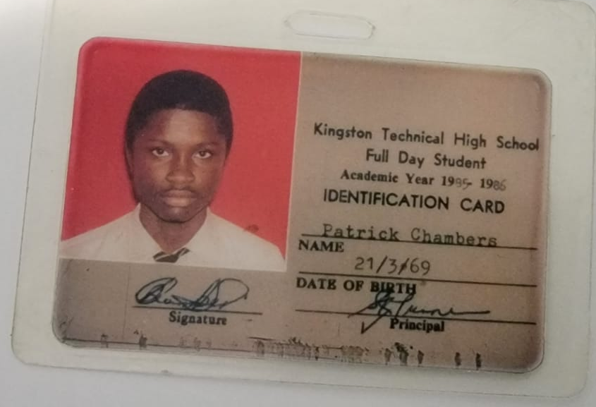



Kwame Ben Eden P.Eng.

Patrick Chambers attended KTHS from 1982-1986. He changed his name to Kwame Ben Eden in 2019. Kwame got accepted in the Quantity Surveyor course at the College of Arts Science and Technology (CAST) currently known as University of Technology, Jamaica
However before he started , he migrated to Toronto, Canada in 1988 to be with his mother.

Kwame attended the Ryerson Polyethnic University where he graduated in 1988 with a degree in Civil Engineering and a certificate in Project Management. He received his license as a Professional Engineer with a PEng designation

Kwame has managed many large and small building projects in the Greater Toronto area like malls and condominium complexes. He currently works for Metrus Construction Limited as a Project Manager. He is managing a $150 Million+ office tower and condominium complex with the Transit line running beneath it in Toronto. He also owns his own consulting firm.

Memorable KTHS moment
Kwame and his friend was caught talking in devotion by Ms. Comrie. Ms. Comrie called his friend up on stage and asked what we were talking about. Kwame was nervous that his friend would divulge the conversation because they were talking negatively about Ms. Comrie’s house, however, he took the blame and Kwame did not get in trouble.

Community Impact
Kwame is a pillar in the diaspora and has a heart for the community. He was an active volunteer for the National Society of Black Engineers Toronto Chapter and mentored many high school students to pursue engineering.

Kwame visited Ghana in 2010 and was shocked at the use of their beach and the lack of sanitary facilities so as a result in 2015 he started the Love Africa Project in Ghana, https://loveafricaproject.com/. He was inspired to fulfill the need to build communal public washrooms, equipped with toilets, sinks and shower stalls - ending open defecation, so as to prevent the spread of preventable and communicable illnesses. Kwame wanted to ensure that he made an impact by building improved sanitation facilities for everyone in the community to help and improve basic hygiene, health and wellness in Salt Pond ,Central Region, Ghana.

Kwame lost his mother in 2021 and to honour her, he is starting a charitable foundation named after his mother, The Veronica Smith Foundation, to award medical scholarships in Canada and Jamaica.

